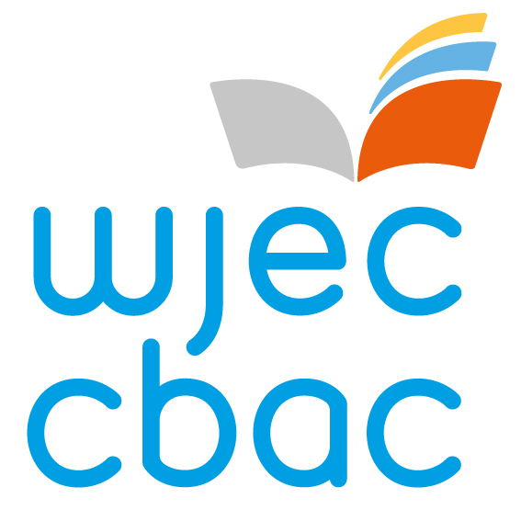
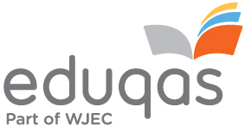
Request for Welsh Medium papers in GCSE and GCE Eduqas qualifications

Centre Number (including any suffix) |  |  |  |  |  |  |  | Centre Name
6 | 8

This centre requests that Welsh medium papers are made available for the June 2024 examinations as follows:

Specification entry code |  |  |  |  | Specification Description | No. of Welsh medium papers requested  For June 2024

Provision through the medium of Welsh can be requested for the following subjects:

Title | GCSE – ON SCREEN | GCSE | AS | Advanced
Electronics | N/A | C490 P1 | B490 QS | A490 QS
Film Studies | N/A | C670QS | B670 QS | A670 QS
Geology | C480 P2 | N/A | B480 QS | A480 QS
Latin (Combination A) | N/A | C990 PA | N/A | N/A
Latin (Combination B) | N/A | C990 PB | N/A | N/A
Sociology | N/A | C200 QS | N/A | N/A

This form must be returned by 17 November 2023 to: eduqaswelshtranslations@wjec.co.uk

Centres are reminded that this request form does not replace the need to make formal candidate entries for these specifications.

WJEC Eduqas cannot guarantee that Welsh versions of papers will be available if this form is received after 17 November 2023.

Signed _________________________________(Head/Examinations Officer) Date ____________
Print name _________________________________ Telephone Number_________________________
Cais am bapurau cyfrwng Cymraeg mewn cymwysterau Eduqas TGAU a TAG

Rhif y Ganolfan (gan gynnwys unrhyw iddodiad) |  |  |  |  |  |  | Enw'r Ganolfan
6 | 8
Mae'r ganolfan hon yn gwneud cais am bapurau cyfrwng Cymraeg yn yr arholiadau canlynol ar gyfer cyfres Mehefin 2024:

Cod Cofrestru'r Fanyleb |  |  |  |  | Disgrifiad y Fanyleb | Nifer y papurau cyfrwng Cymraeg Mehefin 2024 y gwneir cais amdanynt

Gellir gwneud cais am ddarpariaeth Gymraeg ar gyfer y pynciau canlynol:

Teitl | TGAU – ar sgrin | TGAU | UG | Uwch
Electroneg | Amh. | C490 P1 | B490 QS | A490 QS
Astudiaethau Ffilm | Amh. | C670QS | B670 QS | A670 QS
Daeareg | C480 P2 | Amh. | B480 QS | A480 QS
Lladin (Cyfuniad A) | Amh. | C990 PA | Amh. | Amh.
Lladin (Cyfuniad B) | Amh. | C990 PB | Amh. | Amh.
Cymdeithaseg | Amh. | C200 QS | Amh. | Amh.

Rhaid dychwelyd y ffurflen hon erbyn 17 Tachwedd 2023 i: eduqaswelshtranslations@wjec.co.uk

Atgoffir canolfannau nad yw'r ffurflen gais hon yn disodli'r angen i gofrestru ymgeiswyr yn ffurfiol ar gyfer y manylebau hyn.

Nid yw WJEC Eduqas yn gallu sicrhau y bydd fersiynau Cymraeg papurau ar gael, nag y gellir derbyn gwaith wedi'i asesu gan y ganolfan yn Gymraeg, os derbynnir y ffurflen hon ar ôl 17 Tachwedd 2023.

Llofnod _________________________________(Pennaeth / Swyddog Arholiadau) Dyddiad____________
Printiwch Enw _________________________________ Rhif Ffôn _________________________

